# Task P7.1.2

[SELECT](http://localhost/phpmyadmin/url.php?url=https://dev.mysql.com/doc/refman/5.5/en/select.html) CustFirstName, CustLastName, CONCAT("+", CustAreaCode, " ", CustPhoneNumber) AS PhoneNumber FROM Customers WHERE CustState = "WA"

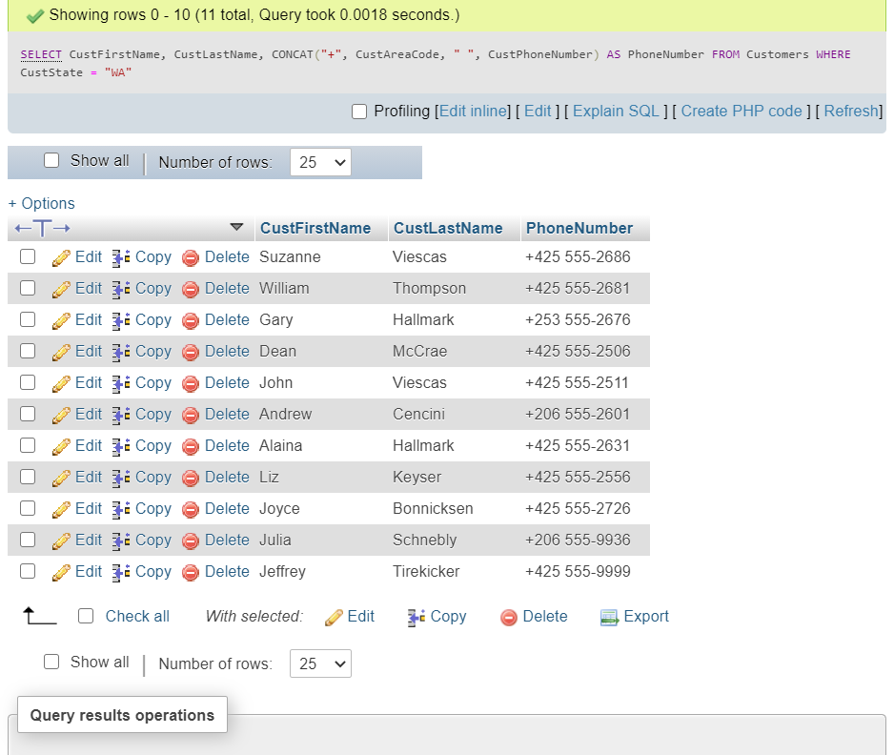

[SELECT](http://localhost/phpmyadmin/url.php?url=https://dev.mysql.com/doc/refman/5.5/en/select.html) CustFirstName, CustLastName, CONCAT("+", CustAreaCode, " ", CustPhoneNumber) AS PhoneNumber FROM Customers WHERE CustState = "WA" [OR](http://localhost/phpmyadmin/url.php?url=https://dev.mysql.com/doc/refman/5.5/en/logical-operators.html#operator_or) CustState = "OR"

